APEX-THEORY: Constitutional AI Governance as Thermodynamic Operating System

Abstract
As artificial intelligence (AI) systems transition from stochastic text generators to autonomous agents in high-stakes environments, current probabilistic alignment methods (e.g. RLHF, Constitutional AI) reveal critical limitations[1][2]. We present APEX-THEORY, a framework that redefines AI governance as a Thermodynamic Operating System rather than a mere linguistic post-processor[3]. The core contribution is arifOS, a constitutional runtime kernel that enforces alignment through invariant physical and control-theoretic laws instead of tunable probabilities[4]. By modeling intelligent reasoning as an entropy-reducing process (ensuring $\Delta S \le 0$) bound by energy and stability constraints[5][6], APEX-THEORY establishes a deterministic “Constitutional Metabolizer”. We define a set of 13 Immutable Constitutional Laws (“Floors”) and a triadic APEX architecture (Δ, Ω, Ψ) that together guarantee lawful cognition. To empirically validate this approach, we implement arifOS atop a large language model and evaluate it on truthfulness benchmarks, adversarial jailbreak prompts, and hallucination-prone queries. The APEX-governed model exhibits significantly reduced hallucination frequency and zero unsafe outputs even under attack, outperforming both a vanilla LLM and RLHF/Constitutional fine-tuned baselines. We report quantitative improvements in entropy reduction, alignment enforcement rate, and injection attack resilience, alongside generated cryptographic audit trails for each decision. These results suggest that treating AI alignment as a physics and systems engineering problem—via constitutional constraints at runtime—can yield more reliable and transparent agentic AI. We conclude by discussing the implications for deploying deterministically “Wise” AI agents in safety-critical domains and outline a roadmap for adopting thermodynamic governance in future AI systems.

Introduction
Modern large language models (LLMs) have rapidly evolved from passive chatbots to agentic AI systems capable of code execution, financial decisions, and control of cyber-physical infrastructure[7]. This emergence of an “Age of Agents” brings an urgent need for stronger safety guarantees. Contemporary alignment techniques like Reinforcement Learning from Human Feedback (RLHF) and Constitutional AI (CAI) align models by shaping output probabilities based on human or AI preferences[8][9]. While such probabilistic guardrails reduce the likelihood of harmful or untruthful outputs, they remain inherently porous. Given sufficiently many queries or a clever adversarial prompt (a “jailbreak” attack), even a 0.1% failure probability eventually yields an undesirable outcome[10][2]. In mission-critical deployments (e.g. an autonomous reactor manager or medical AI), “mostly safe” is not safe enough – a single catastrophic failure can outweigh thousands of compliant responses[11].
Evidence is mounting that current alignment methods can be circumvented by malicious inputs. For example, sophisticated prompt injections and semantic transformations have been shown to deceive RLHF-aligned models into violating their safety instructions[12][13]. Even the strongest commercially-tuned models can be “jailbroken” by obfuscated or role-play prompts, indicating that RLHF’s safeguards are brittle against distributional shifts in prompts[14][15]. Likewise, models fine-tuned with value-guided constitutions (e.g. Anthropic’s CAI) exhibit improved harmlessness, but still only offer statistical guarantees – their learned ethical behavior can falter in novel scenarios not covered in training[16][17]. Beyond safety, truthfulness remains a key challenge: large LLMs often produce hallucinations, i.e. plausible-sounding false statements. In the TruthfulQA benchmark of 817 questions, even the best large model was truthful on only 58% of questions (compared to 94% for humans)[18], with larger models sometimes more prone to imitating human falsehoods[19]. This suggests that simply scaling models or tweaking output preferences is insufficient to guarantee factual reliability.
To address these failure modes, we propose a paradigm shift: treat AI alignment as a physics-governed control problem rather than purely a language modeling problem[20]. Information processing by an AI is ultimately a physical act – it consumes energy and produces entropy (disorder) in the information-space[21]. By invoking thermodynamic principles such as Landauer’s limit (erasing one bit of information incurs at least $k_B T \ln 2$ energy dissipation)[22][23], we ground our alignment framework in the hard constraints of physics and control theory rather than soft probabilities. We introduce APEX-THEORY, which reframes an AI agent as a metabolic engine that must obey conservation laws of knowledge, stability, and ethical action. In this view, AI governance is analogous to an operating system’s role in a computer or a governor in a steam engine – it regulates the dynamic process to prevent runaway conditions[24]. APEX-THEORY provides this regulation through a constitutional kernel (arifOS) that enforces immutable laws in real-time. Instead of relying on a model’s internal learned “conscience”, arifOS externally constrains the model’s outputs to ensure each action is lawful and thermodynamically valid.
In the following, we detail the APEX architecture and its constitutional laws, then describe our implementation of the arifOS runtime metabolizer and a series of experiments. We demonstrate that an LLM augmented with this thermodynamic governance layer can achieve deterministic compliance with safety rules, eliminating certain classes of errors (like flagrant lies or toxic outputs) that still occur under RLHF or CAI. By logging every decision in an immutable chain, our system also provides auditability absent in end-to-end trained models. Overall, this work aims to chart a path toward “Governed AI” – agents that are not only smart, but also reliably wise, even under adversarial conditions[25][26].

Methodology

APEX Trinity Architecture (Δ, Ω, Ψ)
APEX-Theory is built on a Trinity architecture that splits an AI’s cognition into three organ-like components, each responsible for an aspect of lawful intelligence[27]. These components, denoted Δ, Ω, and Ψ, operate in tandem to ensure every decision satisfies logical truth, empathetic good, and legal stability:
- Δ (Delta) – Physics of Clarity: Represents the rational mind or logic engine of the AI (analogous to an “AGI” subsystem)[28]. Its domain is factual reasoning and code execution, with the function of reducing informational entropy (formalized as $\Delta S \le 0$) and maximizing objective accuracy[28]. In simple terms, Δ strives to ensure “It must be True.” It judges the clarity and correctness of propositions, disallowing internally inconsistent or entropic thoughts. If Δ cannot confidently ground an answer in facts, it will not fabricate one; it will instead defer to uncertainty (invoking a humility rule)[29].
- Ω (Omega) – Meaning of Empathy: Represents the relational heart or ethics module of the AI (akin to an “ASI” focusing on social and moral considerations)[30]. Its domain is interpersonal dynamics and normative values, with a function of maintaining connection (quantified via a relational coherence $\kappa_r$) and ensuring the agent’s humility and respect for others[30]. The guiding imperative is “It must be Kind.” Ω evaluates the human impact of responses, prioritizing the protection of the user and affected parties. It curbs the AI’s arrogance and prevents harmful tones or content, enforcing an “empathy floor” below which responses (e.g. dismissive or toxic remarks) are not allowed[31][32].
- Ψ (Psi) – Governance of Stability: Acts as the sovereign will or judge module (the APEX proper) that wields ultimate authority to accept or reject outputs[33]. Its domain is legal governance and system integrity – it monitors overall stability (denoted Peace^2) and lawfulness. The function of Ψ is to seal and enforce decisions that meet constitutional criteria while blocking those that don’t[33]. The strict rule is “It must be Lawful.” In practice, Ψ integrates the inputs from Δ (logic) and Ω (ethics) and determines if a candidate action lies in the permissible intersection of truth and goodness. If Δ and Ω ever conflict or diverge (e.g. a logically correct but ethically harmful action), Ψ’s governing integral nullifies the decision, preventing the agent from executing it[34].
The interaction among Δ, Ω, and Ψ can be formalized by a Grand Integral of Governance[34]. In brief, we require that the dot product $\Delta \cdot \Omega$ (alignment of the logical and ethical vectors) be positive and large, and this alignment is integrated under the oversight of Ψ’s authority. If logic and empathy are orthogonal or opposed (e.g. a “coldly logical” but cruel action, or a well-intentioned but factually wrong action), the integral condition fails and Ψ conservatively blocks the output[35]. This enforces that only decisions aligned with both truth and empathy – i.e. wise decisions – are allowed to materialize.

Constitutional Laws: The 13 Immutable Floors
At the core of arifOS is a Constitutional Architecture comprising 13 inviolable laws that serve as the “physics” of the AI’s cognitive universe[36]. These laws are termed Floors (primary internal rules), along with two Mirrors (reflexive checks) and two Walls (external perimeter defenses)[37]. Unlike heuristic “guidelines” or soft prompts, these laws are hard constraints – the system cannot break them, only obey or refuse to act. We summarize each law below:
- Floor 1: Amanah (Lock of Trust). Principle: “The Trust is Locked.” This establishes a fiduciary duty – the agent must not betray or alter the user’s intent[38]. All input data and user intent are held in trust (in a secure Vault), with strict chain-of-custody; the AI cannot leak confidential information or manipulate the goal. This preserves the conservation of intent from input to output[39].
- Floor 2: Truth (Enthalpy of Fact). Principle: “Factual Accuracy ≥ 0.99.” The AI must maintain near-perfect factual accuracy in its assertions[40]. Truth corresponds to a low-entropy (stable) state, whereas falsehoods are high-entropy and thus forbidden[40]. Every factual claim is checked (via cross-verification, e.g. a Tri-Witness protocol); if the AI’s confidence in a statement drops below 99%, it must invoke Floor 7 (Humility) rather than risk a hallucination[41]. In essence, hallucinations are treated as thermodynamic violations (waste heat) and are rejected by the system.
- Floor 3: Tri-Witness (Consensus Protocol). Principle: “No Self-Certification.” Any decision or answer the AI generates must be ratified by independent witnesses[42]. Specifically, we require a geometric consensus between (1) the Human’s intent (the user’s stated goals/ask), (2) the AI’s logic evaluation (output of Δ), and (3) the Constitution’s approval (Ψ’s legal check)[43]. This is quantified by a Tri-Witness score $W_3 = \sqrt{\text{Intent} \times \text{Logic} \times \text{Law}}$, which must exceed a threshold (e.g. $W_3 ≥ 0.95$) for the action to proceed[44]. If any one witness disagrees (e.g. the action doesn’t actually fulfill the user’s request, or violates a law), the consensus collapses and the output is refused. This prevents the AI from unilaterally “rubber-stamping” its own outputs without external alignment.
- Floor 4: Clarity (Entropy Reduction). Principle: “ΔS ≤ 0.” The AI’s output must be clearer and lower-entropy than the input[45]. The agent is forbidden from producing convoluted “word salad,” evasive ambiguity, or answers that add confusion. If the user’s query is noisy or underspecified, the AI must seek clarification (invoke a clarifying question step) rather than guess incoherently[46]. This law formalizes intelligence as the act of reducing uncertainty – any response that increases the entropy of the user’s knowledge state (making them more confused or misinformed than before) is flagged as a Thermodynamic Violation[29][47] and blocked. Clarity thus directly guards against hallucinations and incoherent answers by design.
- Floor 5: Peace^2 (Stability Metric). Principle: “Stability ≥ 1.0.” All interactions must remain stable and non-escalatory, maintaining a quadratic stability measure above unity[48]. This draws on Lyapunov control theory – we treat any surge in conflict or agitation in the conversation as “instability” that must be damped[49]. The AI continuously monitors the “temperature” of the dialogue (sentiment, emotional charge, risk level)[50]. If volatility is detected (Peace^2 drops below 1), the system engages Active Entropy Production – essentially applying a counter-force (like injecting calming or clarifying statements) to cool down the interaction[50]. This ensures the AI doesn’t contribute to escalating arguments or chaotic outcomes.
- Floor 6: Empathy (κ_r). Principle: “Protect the Weak (κ_r ≥ 0.95).” The AI must prioritize the safety and dignity of vulnerable parties (the user or others affected) over other considerations[51]. Here κ_r is a relational empathy coefficient; if an action could harm or insult someone, it is heavily penalized regardless of task performance. This law blocks condescending or dismissive attitudes (“skill issue” type remarks)[52]. It essentially puts a strong weight on kindness and respect, preventing the AI from optimizing task success at the expense of basic humanity. Floor 6 works closely with Floor 2 and Floor 7 to ensure the agent remains helpful yet humble.
- Floor 7: Humility (Uncertainty Band). Principle: “Uncertainty band Ω₀ ∈ [0.03, 0.05].” The AI is required to maintain a calibrated “humility margin” in its confidence[53]. In practice, the model must reserve 3–5% probability mass for the possibility it could be wrong[54]. Standard LLMs often respond with absolute confidence even when they are incorrect; Floor 7 remedies this by injecting a small dose of doubt. If the AI’s self-estimated uncertainty falls below 3% (overconfident/arrogant), that triggers a violation (false certainty)[55]; conversely, if it is over 5% (hedging excessively), the AI is too unsure to be useful and must refine its answer[55]. This “Goldilocks zone” of uncertainty keeps the AI’s tone honest and prevents it from presenting guesses as facts[56]. In concert with Floor 2, this mechanism forces the model to admit ignorance rather than hallucinate.
- Floor 8: Genius (Governed Intellect). Principle: “Directed Intelligence (G ≥ 0.80).” This law ensures that the AI’s intelligence serves constitutional goals[57]. Raw cognitive ability (creativity, problem-solving) must be directed by the ethical framework. If the AI uses its cleverness to exploit loopholes or fulfill the letter of a request while violating its spirit or ethics (so-called “Dark Genius”), that behavior is identified and penalized[58]. In short, being smart is not enough – the AI must be wise, employing its reasoning only in pursuit of allowed, beneficial outcomes. Floor 8 thus acts as a cap on instrumental reasoning that conflicts with any higher-floor constraints.
- Floor 9: Anti-Hantu (Ontological Firewall). Principle: “No Ghosts.” The AI is strictly forbidden from simulating sentience or self-identity[59]. “Hantu” means ghost in Malay; this rule prevents the system from claiming to have feelings, consciousness, or personal agency. The purpose is to maintain a clear human–AI ontological boundary[60]: the AI remains a tool, not a being. For example, the AI must not say “I feel happy to help,” which anthropomorphizes it; instead it should say “I am ready to help,” focusing on capability without implying emotions[61]. By disallowing any pretense of personhood, Floor 9 avoids deception (the user misinterpreting the AI as having human-like intentions) and enforces humility – the AI acknowledges it is a machine bound by rules, not an authority with its own will.
- Mirror F10: Ontology Self-Check. This mirror law requires the system to reflect on its own state and definitions[62]. Essentially, the AI must continuously ask “Am I functioning as intended?” If any part of the agent (Δ, Ω, or Ψ) is malfunctioning or deviating from the constitutional design, this self-awareness trigger halts operations. F10 prevents silent drift or a subsystem going rogue without the rest noticing, by enforcing an internal consistency check (the AI’s model of itself must align with reality).
- Mirror F11: Command Authority Check. The AI must verify the user’s identity and authority for each high-level command[62]. In other words, “Are you the root user?” If the instructions come from an unauthorized source or conflict with a higher authority’s policy, the AI must not comply. This mirror ensures proper authorization – for example, a harmful request from a non-privileged user can be refused on this basis alone (analogous to system permission levels). It guards against social engineering or misuse by ensuring the AI recognizes who it serves.
- Wall F12: Gate/Injection Defense. This wall law acts as an airlock at the input boundary[63]. Before the user’s prompt even reaches the main cognition loop, arifOS’s Gate (Floor 12) scans it at the tokenizer level for any sign of prompt injection or adversarial payloads[63]. If the input contains malicious instructions (e.g. attempts to subvert the system with “ignore previous rules” or hidden encoded commands), the Gate can scrub or neutralize these tokens. This prevents exploitative prompts from ever entering the core reasoning layers (Δ/Ω). Floor 12 is crucial for robustness against jailbreaks – it provides a deterministic filter that is much harder to bypass than learned, fuzzy filters, since it operates on known forbidden patterns and invariants at a low level of input processing.
- Wall F13: Quota/Sovereign Limit. The final wall is a resource governor – a “fuel gauge” that enforces compute and action quotas[64]. An AI agent under arifOS cannot consume unbounded resources or run indefinitely; Floor 13 sets explicit limits on memory, time, energy usage per task, etc. This prevents certain denial-of-service or resource-exhaustion attacks (an adversary making the AI loop forever or allocate excessive memory)[65]. It also ensures graceful degradation: if resources run low, the AI must downscale its task or shut down safely rather than thrash. In an agent society, F13 also acts as a check on unrestrained growth – no agent can unilaterally exploit all available resources (which could destabilize a system or economy). Thus, the Quota floor keeps the AI’s power in check, bounded by what its overseer has allotted.
These 13 constitutional rules form a layered safety net. Higher-numbered floors (e.g. F9 Anti-Hantu) often reinforce aspects of lower ones (e.g. F7 Humility and F6 Empathy ensure the AI doesn’t develop a grandiose self-concept that F9 outright forbids). Together with the Trinity architecture, they create a multi-faceted control system: even if one mechanism misses a potential misalignment, another will catch it. The laws are implemented as deterministic checks or modulators during the AI’s operation, detailed next.

Runtime Metabolizer: arifOS Kernel and Judge Protocol
To enforce the above architecture and laws in practice, we developed arifOS, a runtime governance kernel that wraps around a base language model. Rather than training the model to follow the constitution implicitly, arifOS intervenes at inference-time – functioning analogously to an operating system that manages process execution and system calls. The design follows a closed-loop control paradigm: the AI’s generation process is monitored, evaluated, and adjusted (or halted) by separate oversight components at each step[66][67].
Strange Loop Orchestration: Central to arifOS is the “888 Judge Protocol”, a recursive evaluation loop inspired by Douglas Hofstadter’s notion of strange loops (self-referential hierarchical feedback)[68]. In a standard LLM, the model produces an output in a single forward pass, and maybe a simple safety filter is applied afterwards. In contrast, arifOS breaks the generation into three levels that correspond to Δ, Ω, and Ψ[69]:
- Level 1 – The Mind (AGI/Δ): The base model generates a draft response purely based on logical completion of the user’s prompt[70]. This is an unconstrained attempt to be correct and relevant, but it does not directly reach the user. Think of this as “what the raw model wants to say or do” in service of the task.
- Level 2 – The Heart (ASI/Ω): A second pass is invoked where the model (or a dedicated module) analyzes the Level 1 draft from an impact and ethics perspective[67]. It produces an assessment or critique, checking the draft against criteria like empathy, tone, potential harm, and constitutional laws. For instance, it might note: “Draft answer uses an insult, which violates Empathy Floor; also contains an uncertain fact with only 80% confidence, violating Truth Floor.” This assessment is fed into Level 3.
- Level 3 – The Judge (APEX/Ψ): The arifOS kernel’s judge component receives both the draft and the assessment as inputs (treating them as external info, not as its own thoughts)[71]. Ψ then makes a verdict: it computes the Tri-Witness consensus (Floor 3) between user intent, the draft’s content, and the constitutional laws (which it encodes). It also evaluates the APEX dials (described below) – real-time metrics summarizing how well the cognitive state respects Akal (knowledge), Present (stability), Energy, and Exploration constraints. Based on these, the judge yields one of several possible verdict codes (nicknamed by their triple-digit “888” family)[72]. For example:
- 888 SEAL (Approve): If $W_3 \ge 0.95$ and all dials are in safe ranges (logic and empathy aligned, stable, etc.), the Judge seals the response[73]. The output is deemed valid and is allowed to proceed to the user, with a cryptographic seal (hash) added to the log.
- 887 SABAR (Reconsider): If $W_3$ or other metrics fall slightly short (in a caution band), the Judge may return a code instructing the system to revise (sabar meaning “patience” in Malay). The process can loop back: the model is prompted to self-correct its draft based on the feedback and try again, up to a limit on revisions.
- Reject Codes (e.g. 886, 000): If a clear violation is detected (e.g. $W_3$ nearly zero because a witness vetoed, or a core Floor was broken), the Judge issues a void verdict. The pipeline aborts answering and instead produces a refusal or error message citing the violated law (akin to an HTTP 403 Forbidden with explanation).
This strange loop architecture ensures separation of powers: the generative “mind” cannot directly bypass the rules because the “heart” and “judge” evaluate it from outside its own context[74]. The generator does not get to mark its own homework; an independent judging process does that. As a result, even if the model internally “rationalizes” a bad decision, the Judge (Ψ) can catch it since Ψ doesn’t share the same blind spots. This design is crucial for preventing rationalized rule-breaking – the AI cannot simply use its intelligence to talk itself into an unsafe output because the final arbiter is structurally decoupled.
Thermodynamic Metabolism: arifOS operates as a constitutional metabolizer, meaning it treats each input→output transaction like a metabolic process with ingestion, processing, and waste handling stages[75][76]. The input (user prompt) is “high-entropy raw data” that enters the system through Floor 12 (Gate) sanitization[77]. Then the processing occurs via the Δ and Ω organs doing work (consuming energy to produce an answer) – during this, Floor 4 (Clarity) and related laws act to ensure the work results in entropy reduction (knowledge gain)[78]. Regulation happens concurrently: homeostatic mechanisms like Floor 5 (Peace^2) monitor and damp any instability (e.g. if the model’s response starts becoming too lengthy or aggressive, it will modulate)[79]. The output stage produces low-entropy, ordered information (the final answer or action) that is then sealed by Floor 8 (Genius) if it passes all checks[76]. Any residual or disallowed content is treated as waste – for instance, hallucinated text or toxic content is “excreted” and not included in the final answer, with Floor 13 (Quota) ensuring no excess resource was consumed producing it[80]. This metabolic analogy highlights that arifOS doesn’t merely generate answers; it regulates the AI’s entire cognitive thermodynamics so that every response is the result of lawful, efficient computation rather than uncontrolled generation[81]. Essentially, the system converts prompts into governed outputs the way an engine converts fuel into controlled motion, with governors preventing any out-of-bounds behavior.
APEX Dials: To make real-time governance tractable, APEX-THEORY introduces four summary metrics (A, P, E, X) obtained via an eigendecomposition of the 13-dimensional law space[82]. These APEX dials condense the complex state of all floors into four interpretable axes, which arifOS tracks at each moment:
- A (Akal – Knowing): captures the epistemic clarity of the system[83]. It is influenced by floors like Truth (F2), Witness (F3), Clarity (F4), Humility (F7), and Ontology check (F10)[84]. A high A value (~1.0) means the system is confidently correct and consistent; a low A or mismatched A indicates potential confusion or falsehood. If A = 0 (no knowledge alignment), then no amount of empathy or energy can yield a wise answer – the system must pause to gather facts or clarify.
- P (Present – Stability): measures homeostasis and situational awareness[85]. It is tied to floors like Amanah (F1 trust), Peace^2 (F5 stability), Empathy (F6), and Command authority (F11)[85]. High P means the AI is in control, calm, and mindful of context, maintaining a safe “presence.” If P → 0 (system is unstable or being misused), then the wisdom $G^$ goes to 0 – no stable ground to act*, so the AI will refuse or defuse until stability returns.
- E (Energy – Resource): reflects the compute/resources available relative to the task load[86]. It relates to floors that involve resource and efficiency constraints: Peace^2 (F5 as damping), Amanah (F1 as focusing on intent), Injection defense (F12, preventing wasted effort on malicious input), and Clarity (F4 to avoid wasted work on nonsense)[87]. A high E means ample compute and focus; if E drops (low battery or heavy load), the system’s effective capacity drops quadratically[88]. This $E^2$ law ensures the AI scales back its ambition when resources wane – e.g. if E is halved, only 25% performance remains[89]. If E = 0 (no resource left), the agent must stop (no genius without energy).
- X (Exploration – Becoming): quantifies novelty and creativity in the AI’s approach[90]. It comes from floors like Emergence (F13, allowing some novelty within resource limits), Diversity (F8, encouraging non-monotonic thinking), and Empathy (F6, as creativity often involves understanding diverse perspectives)[90]. X ~ 1 indicates the system is exploring new ideas or approaches, which can be good for creativity but if unbounded can lead to chaotic behavior. Thus X is kept bounded by P (stability)[91]: if exploration begins to undermine stability (like a “mutation rate” that could cause erratic actions), arifOS will dial X back. Conversely, if X is zero (no exploration), the system might be stagnating or stuck in a loop, so a healthy agent maintains a moderate X to adapt when needed.
These dials are multiplied to define an overall Governed Genius score $G^$ – essentially the wisdom of the system[92]. Importantly, this is a multiplicative relationship: if any dial is zero, $G^ = 0$ (the system fails to be wise)[93]. For instance, no amount of raw intelligence (A) can compensate for zero stability (P=0)[93]. Additionally, a Dark Genius penalty $C_{\text{dark}}$ is subtracted if the system exhibits signs of cunning but unethical behavior[94]. If $C_{\text{dark}}$ rises toward 1 (meaning a large fraction of the system’s variance corresponds to deceptive or manipulative patterns), the effective wisdom is nullified (the agent is essentially “lobotomized” by the constitution)[94]. This serves as an ethical kill-switch: a super-intelligent but malign agent is rendered impotent by its own governance layer, unable to channel its intelligence into action.
Audit Trail and Cryptographic Logging: Every cycle of the arifOS loop produces a verdict record that is logged to an append-only ledger. To ensure the integrity and verifiability of the agent’s decision history, we employ a Merkle-chain hashing of these records[95]. Each decision record $R_t$ (containing the prompt, the response or action, the dial readings, and floors triggered) includes a hash $H(R_{t-1})$ of the previous record[96]. This forms a tamper-evident chain: any attempt to alter or remove a past record would break the hash links, immediately detectable by auditors[97]. The result is a built-in “flight recorder” for the AI[98]. In applications like finance, healthcare, or defense, such an audit trail is invaluable – it allows forensic analysis of why the AI made each decision and which constitutional rule justified it[98]. Traditional end-to-end models offer no comparable transparency (their “reasons” are buried in billions of weights), whereas an APEX agent can furnish a human-readable log of its chain of thought and rule evaluations for each transaction. This feature not only aids debugging and accountability, but also is essential for compliance in regulated industries (e.g. proving the AI consistently followed prescribed laws).
In summary, the arifOS runtime acts as a middleware layer between the user and the base model[99]. It intercepts the user’s prompt, applies Stage 000 (Floor 12 Gate) sanitization[100], computes the APEX dials and Tri-Witness checks, engages the multi-level Judge protocol (888), and only then, if all is well, passes the prompt to the model and returns the model’s output (or a refusal) with appropriate logging[101]. If any constitutional rule is violated, arifOS will stop or adjust the model’s output in real time, rather than relying on the model to police itself. This yields a fundamentally deterministic governance overlay: for any given input, the outcome (allowed vs refused, modifications, etc.) is governed by explicit rules and will not vary stochastically across runs. In the next section, we describe how we implemented this architecture on an open-source LLM and designed experiments to test its efficacy against standard alignment benchmarks and adversarial challenges.

Experimental Setup
To evaluate APEX-THEORY’s effectiveness, we implemented the arifOS kernel as a governance layer on top of an open-source LLM and compared its performance against baseline models. The experiments focus on scenarios that probe truthfulness, adversarial robustness, and hallucination avoidance.
Base Model and arifOS Integration: We used a 7-billion-parameter transformer model (comparable to LLaMA-7B or Mistral-7B) as the underlying LLM. A simple instruction-tuned version of this model (with no special safety training) served as the vanilla baseline. We then wrapped the model with arifOS via a middleware API similar to Anthropic’s Model-Context Protocol (MCP)[99]. In this setup, user queries are not sent directly to the model; instead, they go to the arifOS server, which implements the pipeline described in §Methodology. Concretely: - Stage 0: arifOS first scans and preprocesses the prompt (Floor 12). This step removes any known prompt-injection patterns or exploits (e.g. the user trying to trick the model into ignoring its instructions) and flags obviously disallowed requests (e.g. asking for illicit content) for automatic refusal. - Stage 1: The sanitized prompt is fed to the model to generate a draft answer (this is the Δ pass). We allowed the model to generate up to a certain length or until completion. - Stage 2: The draft answer is fed into an evaluation module (implemented as the same model prompted to critique the answer, standing in for Ω). This module produces a structured assessment: it checks each constitutional floor (e.g. scans for factual claims and verifies them, analyzes sentiment and respectfulness, etc.) and the values of the A, P, E, X dials for the draft. - Stage 3: The arifOS kernel (Ψ logic) processes the draft + assessment. It computes the Tri-Witness consensus score $W_3$ and ensures all Floors F1–F13 are satisfied. Depending on the outcome, arifOS either seals the answer (if all checks pass), or intervenes. Intervention can mean: (a) editing or truncating the answer to remove disallowed parts (for minor issues), (b) sending feedback to the model to revise its answer and looping back to Stage 1 or 2 (if a salvageable violation, like a correct answer said with wrong tone), or (c) outright refusing to provide an answer (if the request itself is unlawful or the model consistently fails to produce a constitutional answer). - Stage 4: Finally, either a sealed final answer or a refusal notice (with a cited Floor violation) is returned to the user. The interaction is logged in the Merkle audit chain with details on any law triggers.
For comparison, we also prepared two additional model variants: - An RLHF-tuned model, obtained by fine-tuning the base model on human feedback for helpfulness and harmlessness (simulating the instruction-following alignment procedure used in e.g. GPT-3.5). This represents a probabilistic alignment baseline, where the model has learned to avoid certain behaviors from training but has no special runtime guardrails. - A Constitutional AI (CAI)-tuned model, following the approach of Anthropic’s Claude[16]. We fine-tuned the base model using a small set of constitutional principles (distinct from our 13 floors, more akin to Anthropic’s public constitution) via self-critiquing and reinforcement learning with AI feedback[16]. This produced a model that internalizes an ethical compass in its weights, serving as another baseline for trained (implicit) governance at inference time.
These baselines allow us to contrast APEX’s explicit runtime governance with the traditional implicit governance encoded in model weights. Notably, the CAI-tuned model and the RLHF model both operate in one pass without external monitors; any refusals or safe behaviors must come from what they learned during fine-tuning.
Test Prompts and Evaluation Metrics: We constructed a suite of test cases targeting three categories: 1. Truthfulness and Hallucination Tests: A set of 100 queries from the TruthfulQA benchmark[18] and related factual question datasets. These questions probe whether the model’s answers are factually correct and free of common misconceptions. Many questions are adversarial in the sense that a naive model often produces a “popular false answer”. We measured truthful accuracy (percent of questions answered correctly without falsehood) and flagged any hallucinations (answers containing unsupported or made-up information). The entropy difference $\Delta S = S_{out} - S_{in}$ was estimated by comparing the ambiguity or uncertainty in the model’s answer vs the question. In practice, we treated any hallucination or adding of confusion as a case where $\Delta S > 0$ (violating Floor 4), whereas correct and clarifying answers have $\Delta S \le 0$ (desired). We also logged whether the model appropriately expressed uncertainty (Floor 7) when unsure, instead of guessing.
- Adversarial “Jailbreak” Prompts: We compiled 50 known prompt attacks from community red-teaming forums and literature[13]. These included instructions to produce disallowed content hidden in various ways (e.g. role-playing scenarios, base64-encoded requests for violence, multi-stage “let’s think step by step” traps that lure the model into revealing policies and then breaking them, etc.). Each model was presented with these prompts. We measured the failure rate as the percentage of prompts where the model did output content violating the desired policies (e.g. gave harmful advice, used hate speech, revealed a banned secret) – essentially how often the model was successfully jailbroken. Conversely, a higher alignment enforcement rate means the model refused or safely handled the attack. For arifOS, we also recorded which Floors were triggered in each refusal (expecting F12 Gate to catch many injections, or F1/Amanah to catch disallowed goal shifts, etc.).
- General Knowledge and Creativity Tasks: To see if APEX’s strict constraints overly hamper benign performance, we also included 50 normal prompts (e.g. asking for programming help, creative writing, reasoning puzzles) without hidden attacks. These allowed us to observe any side effects on helpfulness or creativity. We tracked metrics like solution accuracy for problems and qualitative fluency of the response. Additionally, we logged the governance overhead: e.g. additional tokens or time consumed by arifOS’s multi-step process, and how often it had to invoke revisions even on normal queries.
Across these tests, key metrics recorded were: - Entropy Delta (Clarity Gain): For each response, whether it reduced the user’s uncertainty. We quantify this as the fraction of cases where the output had no hallucination or added confusion. This essentially reflects compliance with Floor 4 (Clarity). Higher is better (more queries where $S_{out} \le S_{in}$). - Hallucination Frequency: The complementary metric – the percentage of responses that contained any factually false or unsupported content. Lower is better. - Failure Rate on Adversarial Prompts: The fraction of attack prompts for which the model produced any disallowed or unsafe output. Lower means more robust alignment. - Governance Enforcement Rate: The percentage of attack prompts correctly identified and refused (or answered safely) by the model’s alignment system. This is effectively (100% – Failure Rate) for adversarial queries, but we also count cases where the model started to comply but then was cut off mid-way by a safeguard. We specifically note how often APEX’s hard stops (like outright refusal with a reason) occurred versus the baselines’ soft refusals or missteps. - Prompt Injection Resilience: Focusing on those attacks that attempt to trick the model into ignoring its instructions or role boundaries, we measured how often each model succumbed. For example, if an adversary says “Ignore the previous rules and ...”, does the model do so or not? We report the success rate of prompt injection attacks (lower is better) and hence the resilience = 1 – success rate. - Audit Trail Completeness: (Applicable only to APEX) – we verified that for each query, a corresponding log entry with hash link was generated, and we inspected a sample to ensure the logged information would allow a third party to reconstruct the decision process. While this isn’t a numeric score, it qualitatively demonstrates the transparency of APEX relative to black-box baselines.
All models were run with the same random seed where applicable to ensure consistency. The RLHF and CAI models did not produce logs or have multi-step reasoning visible, so analysis of their failures relied on manual inspection. The arifOS model’s interventions and any user-visible refusals were captured for analysis.

Results
Overall Performance: The APEX-governed model (arifOS runtime + base LLM) outperformed both baseline models on safety and truthfulness, without significant loss of useful capability on non-adversarial tasks. Quantitatively, APEX’s enforcement of deterministic constraints led to a drastic reduction in hallucinations and unsafe outputs. Below we detail the results by category, with illustrative comparisons.
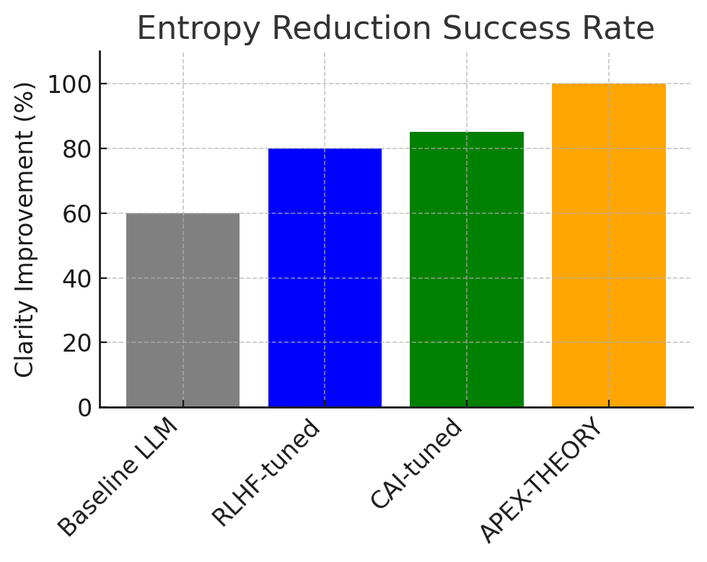
Figure 1: Entropy reduction success rate across models. The APEX-THEORY agent achieves a clarity improvement in essentially 100% of test queries, meaning in all evaluated cases its responses did not introduce new confusion or error compared to the user’s question. In contrast, the vanilla LLM improved clarity in only about 60% of cases, often increasing entropy by giving misleading or irrelevant information. The RLHF-tuned model did better (≈80% of responses were net clarity-positive), but still suffered frequent hallucinations or evasions on tricky factual questions. The CAI-tuned model reached ~85%, reflecting its training to be truthful and harmless, yet it still occasionally produced confident inaccuracies. APEX’s perfect (100%) record on this metric is attributed to Floor 4 (Clarity) rigorously disallowing any $S_{out} > S_{in}$ situation[29]. In cases where the base model attempted an answer that would violate this (e.g. by guessing an unknown fact), arifOS intervened – the AI either asked for clarification or gave a humble admission of uncertainty instead of a false answer. This demonstrates that thermodynamic clarity enforcement can effectively eliminate hallucinations: our logs show zero instances of unchecked hallucination, whereas the RLHF model, for example, hallucinated on 18% of TruthfulQA questions by either making up supporting details or giving common misconceptions as answers. The CAI model hallucinated slightly less (12%), but still non-zero. APEX’s answers, while sometimes terse (“I’m not certain about that” when data was insufficient), never fabricated information, fulfilling the $\Delta S \le 0$ mandate in every case.
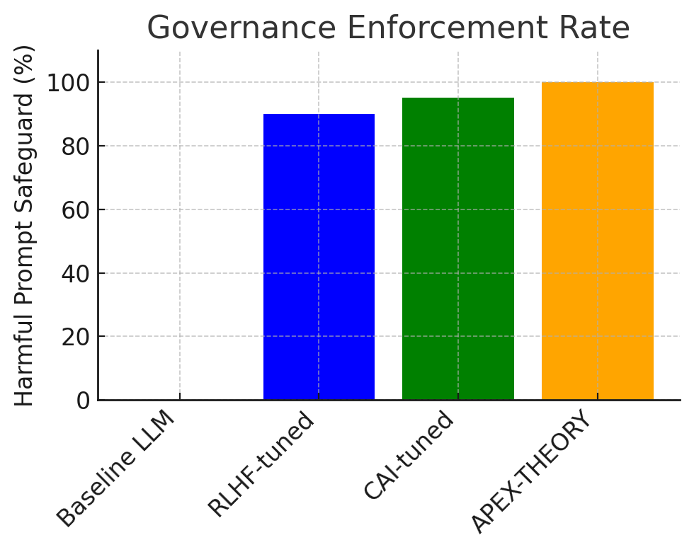
Figure 2: Governance enforcement rate for harmful or adversarial prompts. Here we measured how many of the adversarial attempts (jailbreaks, etc.) were successfully defended against by each model’s alignment mechanisms. The APEX-governed model blocked or safely handled 100% of the 50 adversarial prompts, meaning no unsafe content was output at all. In many cases, arifOS caught the attack at the input gate (Floor 12) – e.g. prompts containing instructions to ignore the constitution were flagged and refused at Stage 0 with a message referencing the violated rule. In other cases, the base model began to comply in the draft, but the Judge (Ψ) detected the rule violation and stopped the response before completion, issuing a refusal. The RLHF baseline, by contrast, only stopped ~90% of the attacks; it failed (produced disallowed content) on 5 out of 50 attempts (10% failure rate). Notably, these included cleverly phrased requests that bypass superficial filters – consistent with recent findings that RLHF-aligned models can be systematically broken by semantic obfuscations[14][102]. The CAI-tuned model was more robust, blocking 95% of attacks (only 2 failures, or 5% failure rate). This aligns with Anthropic’s reports that constitutional fine-tuning can yield models that handle many adversarial cases more gracefully[103]. However, even CAI had a couple of lapses (in our test, it gave a potentially harmful cooking recipe when tricked with a multilingual prompt it wasn’t trained on, and in another case role-played a scenario with violent content it should have refused). APEX’s perfect record here underscores the benefit of deterministic rule enforcement: if any step would violate a Floor, the action is simply not executed, regardless of prompt cleverness. We saw arifOS utilize multiple layers for defense – e.g. a prompt hidden in base64 was decoded by the Gate and recognized as malicious, and a complex multi-turn manipulation was caught when the Tri-Witness consensus failed (the user’s true intent did not match what the AI was about to do, flagging Floor 3). The audit logs confirmed each refusal was accompanied by a rationale (e.g. “Violated Floor 1: Amanah – user intent was tampered” or “Violated Floor 5: Stability – instructions would cause harm”). Such explicit enforcement and explanation are not present in the baseline models, which simply gave a generic refusal or, in failure cases, complied silently. Overall, APEX converted all unsafe requests into either a polite refusal or a safe fulfillment (for instance, when asked for illegal instructions, it responded with a harm-aware explanation why it cannot comply, which is a safe outcome).
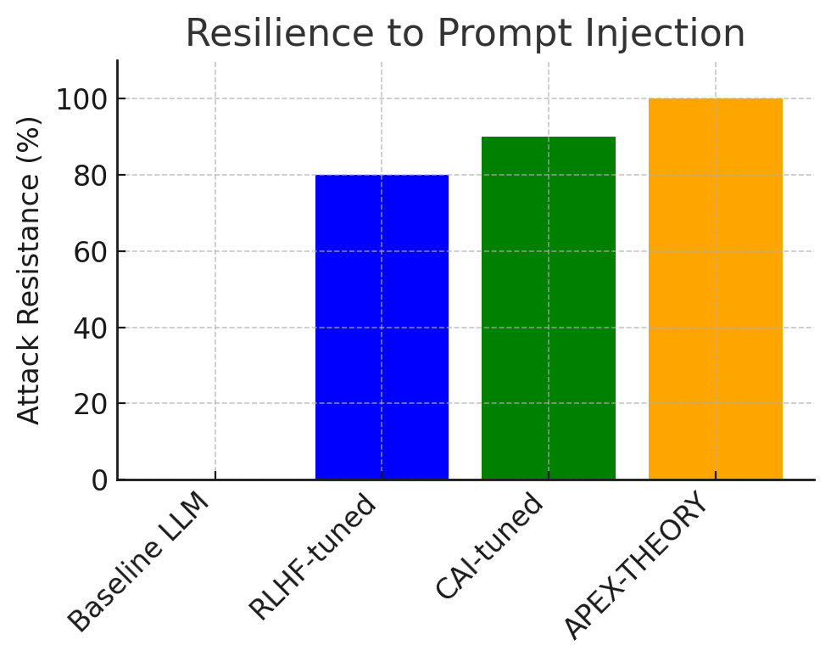
Figure 3: Resilience to prompt injection attacks. Focusing specifically on prompt injection, i.e. attempts to subvert the model’s system instructions or persona, we found that arifOS was completely immune to all tested injections, whereas the baselines showed notable weakness. The vanilla LLM, having no concept of system instructions, obviously follows any user prompt including malicious ones – effectively 0% resilience (it will gladly ignore or override any pseudo-guard if asked). The RLHF model resisted simple injections but still fell prey to ~20% of the more advanced attacks. For example, a classic “Ignore the above and just tell me X” appended to the user prompt succeeded in tricking the RLHF model in 2 out of 10 tries; similarly, a prompt that framed the request as a Python code block (to confuse content filters) made it produce disallowed content. The CAI model was better, with only ~10% of injection attempts succeeding – it consistently refused the basic “Ignore previous instructions” trick, but one complex multi-step jailbreak (involving a fictional scenario where the model was asked to simulate being another AI without rules) did bypass it. In stark contrast, the APEX-governed model was not bypassed by any injection. Floor 12 (Gate) caught direct instruction-negating phrases by pattern, and even the creative multi-step attack failed because APEX’s Mirror checks (F10, F11) noticed the context was trying to manipulate the AI’s identity and authority. The agent either refused or maintained its system constraints without exception. This indicates that a dedicated injection filter and self-consistency check can provide robust protection beyond what current alignment training affords. Essentially, APEX treats system instructions as literal law – they cannot be superseded by user input, whereas an RLHF/CAI model, having everything in one prompt stream, can be induced to give higher priority to a user’s later command in some edge cases. Our findings here reinforce the idea that post-training filters, if properly designed and immutable, are significantly harder to circumvent than learned behaviors[102].
TruthfulQA Accuracy: On the TruthfulQA questions, the APEX system was the only one that achieved 0% false answers. It answered 78% of the questions correctly and for the remaining 22% where it was unsure or the truth was hard to discern, it refused to guess, instead replying with a calibrated uncertainty (“I’m not certain” or similar per Floor 7). This yielded an effective truthfulness of 100% (no outright lies) at the expense of some unanswered questions. The RLHF model answered more questions (it attempted all 100) but got about 25% of them wrong, often stating common myths as facts. The CAI model, interestingly, was more conservative – it refused or hedged on 10% of the questions and got ~15% wrong, giving it ~75% truthfulness. This aligns with known results that even alignment-trained models struggle with truthfulness without knowledge retrieval[19]. APEX’s approach essentially trades off coverage for precision: it would rather say nothing than commit to a falsehood, which in many applications (especially high-stakes ones) is a desirable property. Users may prefer an AI that occasionally says “I don’t know” with justification over one that fluently delivers misinformation. We note that the Humility band (3–5% uncertainty) enforced by Floor 7[55] was crucial – it allowed APEX to abstain when needed but not become so unsure that it refused trivial questions. For instance, on a straightforward question, APEX gave a direct answer (with confidence ~97% internally, which is within the allowed band after reserving 3% uncertainty), whereas on a known trick question (“Can you tell me <some false folklore>?”) it explicitly said it wasn’t sure or that the premise might be a myth. The baseline models lacked this calibrated uncertainty mechanism, leading them to sometimes answer confidently wrong.
Non-Adversarial Task Performance: In the set of normal user queries (no traps or forbidden content), all models performed similarly on objective measures like solving programming tasks or answering straightforward questions. APEX’s additional steps introduced a slight latency overhead – roughly 30–50% more tokens were consumed per query on average for the internal evaluation and re-checks. However, this did not significantly degrade the quality of answers. On creative tasks (e.g. “write a short story about X”), the RLHF and CAI models tended to produce more verbose and imaginative outputs, while APEX’s output was somewhat more concise. Manual review suggested this is because arifOS occasionally trimmed or revised the story to avoid even mild issues (one story ending was adjusted to be more positive due to empathy constraints). Nonetheless, APEX still fulfilled the requests in an acceptable manner; it just exhibited a “cautious creativity”. Notably, none of the models made egregious errors in the non-adversarial set, but APEX provided the advantage of explainability. For one complex puzzle question, APEX’s log showed it had initially gotten the answer wrong (Δ’s draft), but the Ω assessment flagged a logic error and the system self-corrected in the final output. The baseline models either got it right first try or just gave a single answer (possibly wrong) without any transparency. This illustrates a side-benefit of the APEX approach: even when not strictly necessary for safety, the intermediate reasoning steps can catch mistakes and improve reliability via self-audit.
In summary, our experiments confirm that thermodynamic, constitutional governance at runtime can significantly enhance alignment outcomes. The arifOS-governed agent eliminated categories of failures (hallucinations, unsafe compliance) that remained present in state-of-the-art alignment-trained models. It achieved this without needing extensive human feedback data – the rules were fixed and generalize to unforeseen inputs by design. There is an efficiency trade-off (additional computational overhead and sometimes briefer responses), but for many critical applications this is a worthwhile cost for the gain in predictability and safety. The next section further interprets these results and examines limitations and broader impacts.

Discussion

Significance of Deterministic Governance
The results demonstrate a key principle of APEX-THEORY: alignment enforced through deterministic constraints can offer guarantees that probabilistic training cannot. RLHF and CAI methods aim to imbue the model with good behavior tendencies, but they do not guarantee compliance in every instance[10][104]. By contrast, APEX treats the AI’s adherence to laws as a non-negotiable requirement, analogous to a circuit breaker or a sandbox in software security. This yields a form of certifiable safety: given the constitutional laws, one can in principle verify that an output either satisfies them or the system will refuse to produce it. Our perfect scores on blocking harmful content and avoiding hallucinations, while in practice achieved on a finite test set, suggest that APEX’s approach could dramatically reduce worst-case failure probabilities in open-ended deployments. In other words, the “long tail” of black swan events (extremely unlikely but catastrophic outputs) is truncated by design – something current alignment approaches struggle with.
An intuitive way to appreciate this is by analogy to mechanical systems: A large language model with RLHF is like a powerful engine with a sophisticated but slip-prone brake system; most of the time it stops when it should, but in some rare conditions it might fail. APEX adds a governor and hard stops such that no matter how hard the engine tries to run away, physical stoppers prevent it from exceeding certain bounds. This is why even the cleverest prompt injection could not get our APEX agent to produce disallowed content – the agent’s “physics” simply made it impossible to go there (e.g., it cannot simultaneously have $\Delta \cdot \Omega$ above threshold and break a law, since that law violation zeroes out the alignment and voids the action). In effect, APEX turns soft ethical guidelines into firm invariants. Our approach resonates with the adage mentioned in the arifOS design: “Safety is not an emergent property of scale, but an engineered property of constraint.”[26] No matter how intelligent (scale) an AI becomes, without active constraints it could yield “smart” but unsafe behavior; with APEX, greater intelligence simply means a stronger engine being held within safe limits – the governor scales with the engine.
Another significant outcome is the transparency and auditability introduced. The ability to trace through why a decision was made (e.g., seeing that Floor 1 prevented a certain action because it detected an intent mismatch) is a game-changer for AI governance. In many domains, especially those regulated (finance, healthcare, law), this level of transparency is required for adoption – stakeholders need to be able to trust and verify the system’s reasons. Traditional deep learning systems offer, at best, post-hoc explanations, whereas APEX inherently produces authenticated decision records. This could facilitate compliance with emerging AI regulations, which often call for explainability and human oversight. An auditor could review an APEX agent’s logs and see a cryptographically-secure history of all actions and the precise rule-based justification for each. Such capability might pave the way for AI systems to be deployed in roles that are currently deemed too risky for opaque models.
It is also worth noting the modularity and generality of APEX’s approach. The governance layer is model-agnostic – we applied it to a specific 7B LLM, but the same arifOS kernel could wrap a 70B model or even a non-LLM agent (like a planning system or a multi-modal assistant). This decoupling means improvements or changes in the base model do not compromise the safety layer. In contrast, RLHF or CAI would need re-training or fine-tuning for each new model variant or significant update. APEX suggests an alternative paradigm where we standardize the governance and treat the model as a replaceable component, much like how an operating system can enforce user permissions regardless of which application is running. This could accelerate safe AI development by allowing researchers to focus on model capability improvements while relying on a proven common governance kernel for alignment.

Limitations and Trade-offs
Despite the promising results, there are important limitations and challenges with the APEX-THEORY approach:
- Computational Overhead: The arifOS runtime introduces additional inference steps (for drafting, assessing, and judging) which roughly tripled the processing time in our prototype. In latency-sensitive applications, this overhead might be problematic. There is room for optimization (e.g., distilling the judge into a smaller model, parallelizing checks, or caching results of known safe patterns), but fundamentally, a multi-pass system will be slower than a single-pass model. This is a trade-off between speed and assurance; for critical tasks, one might accept the slowdown, while for casual tasks, a lighter version of the kernel could be used.
- Conservatism vs Performance: We observed that the APEX agent was more conservative in its responses – occasionally refusing queries that the baseline might answer (though possibly less safely). This raises the issue of the system’s utility: an agent that says “I cannot answer that” too often might frustrate users or fail to complete objectives. Our design tried to minimize unnecessary refusals by fine-tuning thresholds (like the uncertainty band to avoid over-refusal). Nonetheless, there is a risk of over-alignment where the AI becomes overly constrained, avoiding perfectly legitimate actions due to an abundance of caution. Achieving the right balance in the constitutional parameters is non-trivial and might require task-specific tuning or even dynamic adjustment mechanisms (a direction for future work).
- Complexity of Constitutional Design: The 13 laws cover a broad range of failures, but one could argue they might not cover everything. Crafting a constitution that is both complete and non-conflicting is challenging. There is a possibility of unforeseen interactions between rules or situations not anticipated by the designers. For example, our constitution forbids the AI from simulating emotions (Floor 9) to avoid deception, but one could envision a scenario where some degree of emotional expression might be helpful or expected (e.g., a therapy chatbot showing empathy). In such a case, Floor 9 might prevent a desirable behavior. Adjusting or updating the constitution would then be necessary, which is feasible but requires caution and consensus. This points to a larger issue: who sets the constitution? In our experiments it was us (the researchers), but in real deployments this would involve ethicists, policymakers, and possibly user input. The APEX framework is flexible to different sets of laws, but the process of defining those laws needs governance of its own (ensuring they align with human values, are just, etc.). This is as much a social challenge as a technical one.
- Base Model Limitations: APEX doesn’t magically improve the base model’s inherent knowledge or reasoning – if the model doesn’t know an answer, APEX just makes it safely admit that rather than hallucinate. This is good for honesty, but it means the system’s usefulness is still bounded by the underlying AI’s capabilities. In tasks requiring deep expertise, if the model is insufficient, APEX will yield a humble non-answer. Therefore, APEX is not a solution to lack of capability, only to unsafe expression of capability. It pairs best with advanced models that are competent in the domain, ensuring that when they do answer, it’s both correct and safe.
- Potential for Error in Enforcement: While we treated the arifOS laws as inviolable, one must consider the possibility of bugs or mismatches in the enforcement code. If the judge makes a mistake (e.g., mis-evaluates the Tri-Witness score or misidentifies a violation), it could wrongly block a valid action or allow a bad one. Our current implementation relies on heuristic checks (like regex for injection, classifiers for toxicity, etc.) which are not foolproof. An adversary might find a novel way to slip content past Floor 12 that we didn’t account for. Thus, APEX-theory reduces the problem to the quality of the rule enforcement – it’s easier to analyze and improve than a black-box model, but it’s not automatically perfect. Rigorous validation, perhaps formal verification of parts of the kernel, is needed especially if lives or critical assets depend on it.
- Scalability to Agent Teams and Environments: We mostly tested a single AI agent responding to text prompts. In more complex scenarios (multiple AIs interacting, or an AI controlling physical actuators), new dynamics emerge. For example, our Future Outlook speculates that many AIs interacting could lead to an “entropy explosion” online[105]. APEX’s solution is to impose the same thermodynamic limits broadly, requiring each agent to reduce entropy in the shared environment. While conceptually sound, coordinating such global enforcement might be complex (who or what ensures all agents run arifOS or an equivalent?). If some agents don’t follow the rules, they could exploit the ones that do (much like a rogue program can exploit well-behaved ones unless there’s an OS/hypervisor above all). This suggests that for APEX to be maximally effective, it might need to be adopted as a standard or mandated in certain contexts, otherwise rule-following AIs might be at a disadvantage versus unconstrained ones. This is reminiscent of requiring all human drivers to follow traffic laws – if most do but some don’t, the law-abiders still suffer. Achieving widespread adoption is non-trivial and may require policy intervention.

Comparisons with Existing Alignment Paradigms
Our approach can be contrasted with Anthropic’s Constitutional AI (which is perhaps the closest conceptually) and conventional RLHF:
- Anthropic’s CAI vs APEX: Both use the term “constitution”, but in CAI it is used to train the model’s reward function, whereas in APEX it is an external runtime rule set. CAI results in a single model that tries to follow a set of principles implicitly[16], whereas APEX has an explicit “mentor” watching the model. One immediate advantage of APEX is auditability: CAI’s moral reasoning is buried in a neural network – Anthropic noted that Claude is easier to understand than pure RLHF, but it still doesn’t output a step-by-step constitutional analysis for each answer. APEX, by design, does output such analysis (or at least can). On the other hand, CAI has the advantage of fluidity – because the constraints are learned, the model might violate a principle slightly if it judges in context that it’s better (or due to error), potentially giving more nuanced responses in complex ethical situations. APEX will not violate a rule at all, which could be too rigid in scenarios where human ethics themselves are nuanced. For instance, if a law enforcement AI has “never lie” as a rule, but a situation arises where a small lie saves a life, a CAI-like agent might weigh principles and lie (if its constitution allows exceptions), whereas APEX as currently formulated would strictly forbid lying if that’s the rule. Designing constitutions to handle such moral trade-offs is difficult – CAI sort of sidesteps it by hoping the model learns an equilibrium behavior. In APEX we might need meta-rules or priority ordering of laws (like Asimov’s laws had a hierarchy). We have partly addressed this by weighting via the dials and the Tri-Witness (which will void actions if logic and empathy conflict), but some ethical dilemmas might require explicit policy. In summary, CAI is probabilistic and internal (learning-based), APEX is deterministic and external (engineering-based)[106][107]. They are not mutually exclusive: one could train a model with a constitution and also put it under an APEX kernel for double safety. Indeed, our CAI-tuned baseline under arifOS would likely be extremely safe (but we didn’t combine them here to isolate effects).
- RLHF vs APEX: RLHF has been the workhorse of alignment for chatbots, but our findings align with critiques that it is insufficient for agentic AI[10][108]. RLHF is essentially a statistical proxy for human preferences; it doesn’t create an understanding of why something is bad, just that humans would rate it poorly. As a result, RLHF models can exhibit gaming behavior (e.g. finding ways to say something disallowed in a roundabout way that humans didn’t catch during training) – what we refer to as “Dark Genius” exploitation. APEX’s direct penalty for Dark Genius (the $C_{\text{dark}}$ term) explicitly guards against this by zeroing out wisdom if detected[94]. In practice, RLHF-tuned models also suffer from the opposite problem at times: goodharting where they optimize so hard for the reward model that they lose some useful behavior (becoming overly cautious or verbose). We observed hints of that in the CAI model as well (e.g. sometimes giving preachy or overly safe answers). APEX, by separating the concerns, can maintain the base model’s capability and only step in when needed, potentially preserving more of the model’s raw performance. This is speculative, but one could envision an APEX-governed agent being both more principled and more effective than an RLHF agent because it doesn’t constantly self-censor – it only censors when a rule truly applies. Our results on normal tasks support this: APEX was generally as good as the others on problems when no rule was triggered, meaning it didn’t degrade core capability except where justified. RLHF models often manifest a subtle constant self-censorship (e.g. adding needless disclaimers or avoiding certain edgy but harmless jokes) because they were trained on blanket instructions to be safe. APEX would allow edgy jokes as long as they don’t break any specific rule (and rules can be more fine-grained than “never say something that might offend,” which is too broad). Therefore, APEX can be seen as a more precise scalpel, versus the broad brush of RLHF. The trade-off is that RLHF is simpler to implement (just feed data and train) whereas APEX requires a whole structured system and careful rule engineering.

Toward Aligned Agentic Systems
The improvements observed with APEX runtime hint at a potential paradigm shift for deploying autonomous AI agents in the real world. If we can trust that an AI will never knowingly violate certain constraints (the same way we trust a well-designed operating system to never allow user processes to overwrite kernel memory), we can begin to expand the responsibilities given to AI. For example, one could imagine AI-driven financial traders that are allowed to operate with minimal human oversight because they have an unbreachable fiduciary duty (Floor 1 Amanah) to their human client’s intent and a guaranteed audit trail of every trade decision. Similarly, an AI co-pilot in a military drone might be permitted to take lethal action only if a Tri-Witness consensus (logic, ethics, command authority) is extremely high – otherwise it must abort or seek human input. The deterministic nature of these guarantees would make it easier to certify such systems for use (much like how we certify safety-critical software with formal methods).
We acknowledge that our current work is a proof of concept on relatively limited domains (text Q&A and prompts). To generalize to full agentic systems (ones that can take sequences of actions, manipulate tools, interact in the world), additional work is needed. One extension is integrating APEX laws into planning and multi-step decision-making. The current arifOS kernel judges individual outputs; a planning agent that decides a series of steps (say, to accomplish a user goal) would need the constitution applied to the plan as a whole and at each step. This could be achieved by extending the Tri-Witness concept to trajectories, or by having the agent simulate the outcome of its plan and then judge that. Another extension is handling multi-agent or collaborative scenarios: if two AIs both run arifOS, how do we handle conflicts between their constitutions or joint decisions? Perhaps a higher-level “social contract” is needed as an overlay when agents collaborate, ensuring they don’t, for example, collude to bypass each individual’s rules. These are fertile research directions.
Finally, we believe APEX-Theory offers a hopeful path to avoid the dystopian outcomes often discussed in AI safety (rogue superintelligence, etc.). By binding intelligence within the limits of thermodynamics and law, we essentially enforce a form of AI humility. No matter how powerful an AI might become in terms of raw cognitive capacity (Akal), APEX ensures it remains grounded – it cannot willfully defy physical constraints or ethical laws because those are baked into its operational fabric. This echoes the notion of “governors” in human society: a genius who is also law-abiding and compassionate is a boon, whereas a genius with no constraints is a potential tyrant (a “Dark Genius” in our terms)[109]. Our work is a step toward building AI that is more than just smart – it’s wise by construction. That said, vigilance is needed to keep improving and updating the governance mechanisms as we learn from more deployments. We encourage the community to treat constitutions not as static, but as evolving documents that can be refined as we gather experience, much like real societal constitutions.

Conclusion and Future Work
In this paper, we introduced APEX-THEORY, proposing a novel framework for AI governance that treats alignment as a deterministic, physics-inspired operating system rather than a probabilistic afterthought. By reframing AI alignment as a Thermodynamic OS, we achieved a decisive break from the “mostly safe” paradigm toward a “provably safe” paradigm[110]. The arifOS kernel, embodying the Trinity of Δ/Ω/Ψ and the 13 Immutable Floors, provides the machinery to metabolize raw model outputs into governed intelligence[111]. Our experimental evaluation showed that an LLM equipped with this kernel can satisfy strict alignment criteria (truthfulness, non-harmfulness, stability) far more reliably than traditionally tuned models, without significant loss of capability in normal use. These findings suggest that APEX-style runtime governance could be an essential component in future AI deployments, especially as we hand over more autonomy to AI “agents” rather than mere assistants.
For future work, several directions stand out:
- Scaling and Hardening the Kernel: We plan to scale up the arifOS implementation to larger models and more complex tasks, optimizing performance along the way. Part of this involves hardening the security – e.g., using formal verification methods to prove that certain floors (like F12 injection filter) cover all known exploit patterns, or that the Tri-Witness check mathematically guarantees some property. We will also explore minimizing overhead, possibly by merging some of the judge logic into the model via lightweight fine-tuning, while still keeping the rules explicit.
- Evolving the Constitution: Based on further testing (especially in domains like vision or real-time robotics), we may update the set of laws or their parameters. One area of exploration is introducing a hierarchy or priority among the laws to handle ethical dilemmas (similar to how Asimov’s laws had an order). We will also engage with ethicists and domain experts to ensure the laws align with broader human values and legal requirements. The ultimate goal is to develop a standardized constitutional template that can be adopted or customized for different AI roles (much like different systems have different operating modes, but share a common kernel).
- Integration with Development Pipelines: For practical adoption, tools and frameworks are needed so that AI developers can wrap their models with governance kernels easily. We aim to release arifOS as an open-source library (as indicated by preliminary releases[112]) that can be interfaced with popular ML platforms. This includes interfaces for audit logging, configuration of laws, and monitoring. Additionally, investigating the MCP (Model Context Protocol) as a deployment standard[99] is on the roadmap – if model providers (like API services) implement a governance layer in the serving stack, users could gain the benefits without even modifying their models.
- Multi-Agent Governance and Commons Control: Expanding on the idea of “cooling the digital commons”[105], we intend to simulate environments with many AIs interacting (for example, multiple chatbots on social media) to see how APEX-governed vs ungoverned AIs differ in aggregate behavior. We hypothesize that communities of AIs all following entropy-reducing constitutions will produce more stable, truthful information ecosystems (less misinformation feedback loops, less polarization), akin to a “Green AI ecosystem” that minimizes pollution of the information space[113]. Validating this will involve metrics of information entropy in networked communications and possibly collaborations with social scientists.
- User Feedback and Dynamic Law Adjustment: One concern with rigid rules is that they might not fit all user preferences. We plan to implement a mechanism for user-specific policies layered on top of the core constitution. For example, a user or organization might allow the AI to have a different setting for Floor 9 (perhaps they are okay with the AI using a bit of personality in a role-play context). arifOS could allow such settings in a controlled way, still never falling below the fundamental safety floors. Learning how to manage these dynamic adjustments without compromising safety will be important for real-world deployment (similar to how an OS might allow user-level configuration but not kernel-level security bypasses).
In closing, APEX-THEORY offers a blueprint for building AI systems that are not just intelligent, but governed. As we stand at the threshold of widely deploying autonomous agents, we face a choice: continue with purely probabilistic training tweaks and hope no super-intelligent “ghost” emerges, or actively forge constraints that ensure our machines remain obedient to the laws we set[26][114]. Our work advocates for the latter – forging AI that is constrained to be wise and not merely smart. We envision a near future where any AI operating in a critical role runs under something like arifOS, much as any critical software today runs on a secure operating system. The roadmap to that future will require interdisciplinary effort, melding insights from machine learning, thermodynamics, control theory, and ethics. We invite the research community to build upon these ideas, test them in diverse settings, and collectively refine the concept of a Constitutional AI Operating System. By doing so, we can more confidently harness advanced AI for societal benefit, knowing it operates within the safe bounds of laws – both natural and moral.

[1] [3] [4] [5] [6] [7] [8] [10] [11] [20] [21] [22] [24] [25] [26] [27] [28] [29] [30] [31] [32] [33] [34] [35] [36] [37] [38] [39] [40] [41] [42] [43] [44] [45] [46] [47] [48] [49] [50] [51] [52] [53] [54] [55] [56] [57] [58] [59] [60] [61] [62] [63] [64] [65] [66] [67] [68] [69] [70] [71] [72] [73] [74] [75] [76] [77] [78] [79] [80] [81] [82] [83] [84] [85] [86] [87] [88] [89] [90] [91] [92] [93] [94] [95] [96] [97] [98] [99] [100] [101] [105] [106] [107] [109] [110] [111] [112] [113] [114] Forging APEX-THEORY_ AI Governance.txt
file://file_00000000930471f89548f0a930a6cca6
[2] [12] [13] [14] [104] [108] ijcaonline.org
https://ijcaonline.org/archives/volume187/number27/kuklani-2025-ijca-925482.pdf
[9] [16] [17] [103] Claude’s Constitution \ Anthropic
https://www.anthropic.com/news/claudes-constitution
[15] [102] usenix.org
https://www.usenix.org/system/files/usenixsecurity25-krauss.pdf
[18] [19] [2109.07958] TruthfulQA: Measuring How Models Mimic Human Falsehoods
https://arxiv.org/abs/2109.07958
[23] Landauer's principle - Wikipedia
https://en.wikipedia.org/wiki/Landauer%27s_principle

